# SE PROJECT REPORT

Table of Contents

SE PROJECT REPORT 1

WORK DISTRIBUTION 3

INTRODUCTION 3

PROJECT OBJECTIVES 3

SCOPE OF THE PROJECT 4

DATABASE 4

TABLES 4

NORMALISATION (UPTO BCNF) 4

PATIENT ERD 6

UNIFIED ERD 6

SCHEMA DIAGRAM (PATIENT MODULE) 7

DML OPERATIONS 7

FUNCTIONAL REQUIREMENTS 11

FR01: PATIENT REGISTRATION 11

FR02: PATIENT LOGIN 12

FR03: PERSONALIZED DASHBOARD 12

FR04: MEDICAL RECORDS MANAGEMENT 12

FR05: PATIENT PROFILE 12

FR06: PRESCRIPTIONS 12

FR07: APPOINTMENTS 12

FR08: PRESCRIPTION-APPOINTMENT ASSOCIATION 13

NON-FUNCTIONAL REQUIREMENTS 13

NFR01: SCALABILITY 13

NFR02: USABILITY 13

NFR03: MAINTAINABILITY 13

USE-CASE 14

WIREFRAME 14

FRONT-END 15

DFD 21

LEVEL 0 21

LEVEL 1 22

GITHUB LINK 22

TESTING 22

STATE TRANSITION TESTING 22

## WORK DISTRIBUTION

|  |  |  |
| --- | --- | --- |
| **TEAM MEMBER** | **ENROLLMENT** | **MODULE** |
| Muskaan Adil | 02-134221-028 | Back-end |
| Aleena Khalil | 02-134221-078 | Database |
| Ujala Wasil | 02-134221-004 | Front-end |
| M. Hadi Mansoor | 02-134221-034 | Database |
| M. Sahl Bin Asim | 02-134221-080 | Requirement / Documentation |
| Syed M. Sabih | 02-134221-037 | UI/UX |
| Rana Abdullah | 02-134221-033 | Testing |

## INTRODUCTION

This report details the implementation and functionalities of the Patient Module of the Hospital Management System. The Patient Management System aims to streamline patient care processes, enhance efficiency, and improve the overall patient experience. This document outlines the system's features, including patient registration, patient login, personalized dashboard, medical records management, patient profile, prescriptions and appointments. Additionally, the report discusses the benefits of the management system for both patients and healthcare providers, highlighting improved data accessibility and reduced administrative burden.

## PROJECT OBJECTIVES

* **Reduce wait times:** Automate tasks like patient registration, login, appointment scheduling, and potentially prescription refills to minimize patient wait times in the clinic or hospital.
* **Improve appointment management:** Offer online appointment scheduling and cancellation capabilities, allowing for greater flexibility and convenience for patients.
* **Empower patients:** Provide secure access to a personalized dashboard where patients can view medical records, prescriptions and upcoming appointments.
* **Centralized Health Record:** Establish a secure and centralized repository for all patient medical records, ensuring authorized personnel have immediate access to complete and up-to-date information.
* **Enhanced data accuracy:** Streamline data entry processes to minimize errors and inconsistencies in patient information.
* **User Friendly Interface:** Creating a user friendly environment for the user to make the management system more efficient.
* **Reduce Administrative Burden:** Automating repetitive tasks like appointment scheduling etc. should be automated.

## SCOPE OF THE PROJECT

* **Patient Registration and Management:** Automate patient registration, login processes, and manage patient profiles.
* **Appointment Scheduling and Management:** Implement online appointment scheduling, cancellation capabilities, also the details of the appointments for example the doctor, day etc.
* **Health Records:** Develop a secure, centralized repository for all patient medical records, including medications and lab results.
* **Prescription Management:** Should enable the user to view the medications, what is diagnosed and also the duration of the medications.
* **Treatment Plan:** This should allow the user to view the ongoing treatments and also the completed treatments.
* **Patient Portal:** Develop a secure patient portal where patients can access their medical records, view upcoming appointments and prescriptions

## DATABASE

### TABLES

* Patient (PatientID, PatientName, DOB, Gender, Contact, Address, Email, Password, Status)
* Appointment (AppointmentID, PatientID, DoctorID, Date, Time, Status)
* Diagnosis (DiagnosisID, DiagnosisName)
* Prescription (PrescriptionID, AppointmentID, ClinicalNotes, Status, Date)
* PrescriptionDiagnosis (PrescriptionID, DiagnosisID, Date, Description)
* Medicine (MedicineName, ManufacturerID, Category, ManufacturingDate, ExpiryDate, PricePerUnit)
* PrescriptionMedicine (PrescriptionID, MedicineID, Frequency, Quantity, Dosage, Instructions, MedicineDuration)
* MedicalHistory (MedicalHistoryID, PatientID, TreatmentHistory, Allergies, PreviousSurgeries, FamilyHistory)
* PatientTest (PrescriptionID, TestID)
* Doctor (DoctorID, Specialization, Status, OPDCharges)

### NORMALISATION (UPTO BCNF)

#### TABLE: LOGIN

* Email (Primary Key)
* Password

#### TABLE: PATIENT

* PatientID (Primary Key)
* FirstName
* LastName
* DateOfBirth
* Gender
* ContactNumber
* Address

#### TABLE: APPOINTMENTS

* AppointmentID (Primary Key)
* AppointmentDate
* AppointmentTime
* Status
* PatientID (Foreign Key)
* DoctorID (Foreign Key)

#### TABLE: MEDICALHISTORY

* MedicalHistoryID (Primary Key)
* PatientID (Foreign Key)
* Diagnosis
* TreatmentHistory
* Allergies
* PreviousSurgeries
* FamilyHistory

#### TABLE: CLINICALNOTES

* NoteID (Primary Key)
* NoteContent
* NoteDate
* AppointmentID (Foreign Key)
* DoctorID (Foreign Key)

#### TABLE: TREATMENTPLANS

* PlanID (Primary Key)
* Diagnosis
* TreatmentDescription
* StartDate
* EndDate
* PatientID (Foreign Key)

### PATIENT ERD

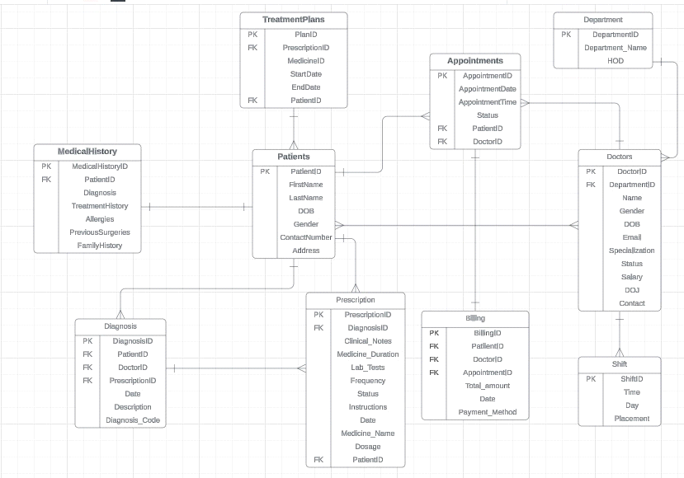

### UNIFIED ERD

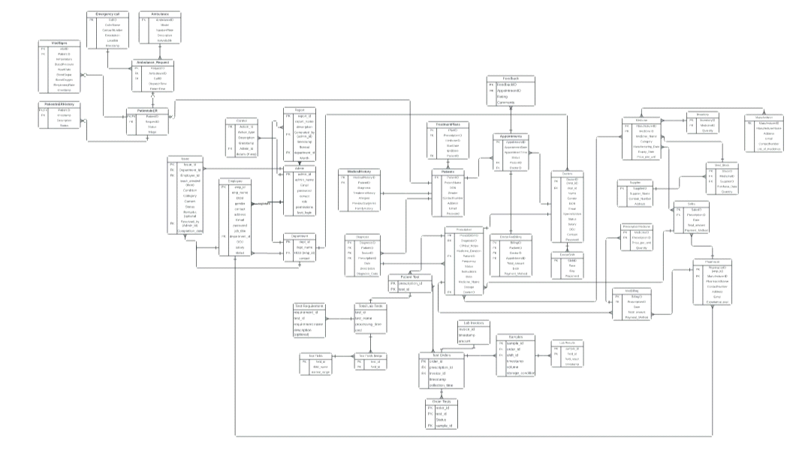

### SCHEMA DIAGRAM (PATIENT MODULE)

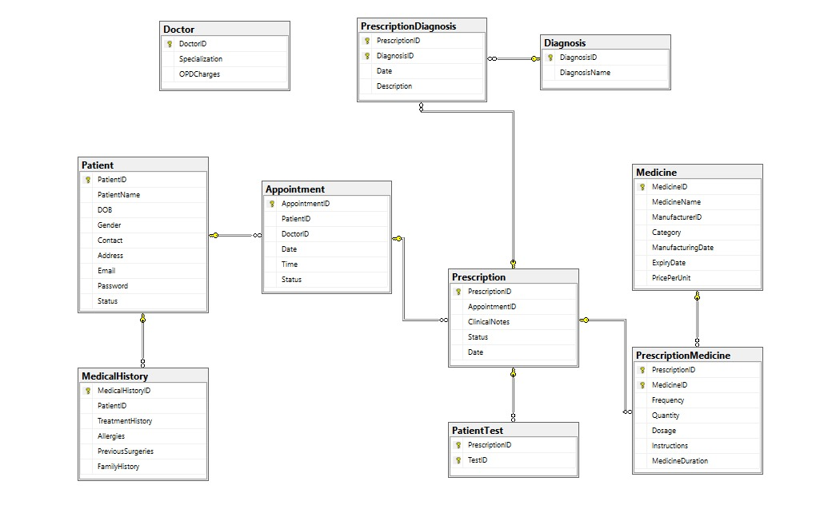

### DML OPERATIONS

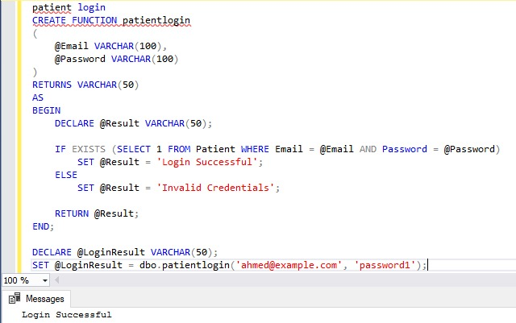

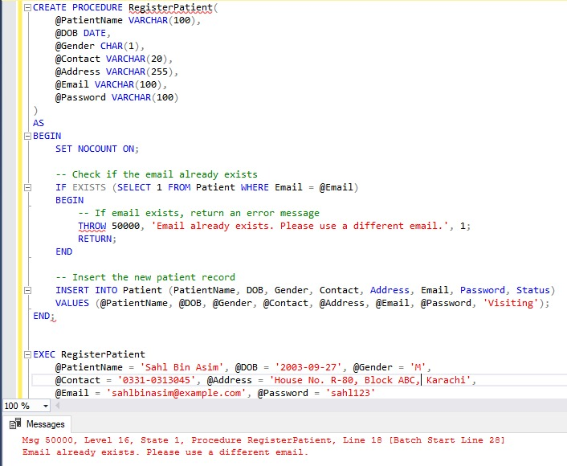

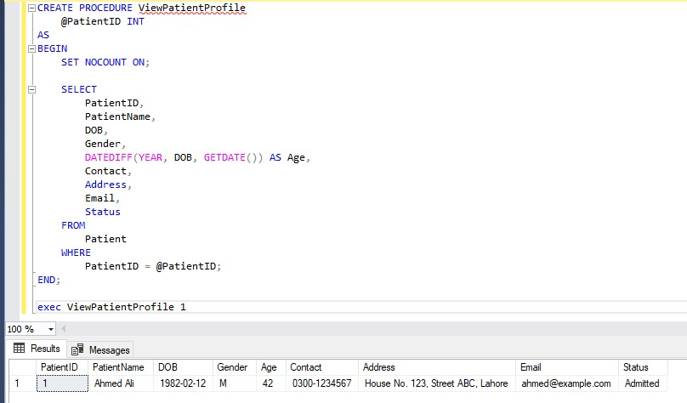

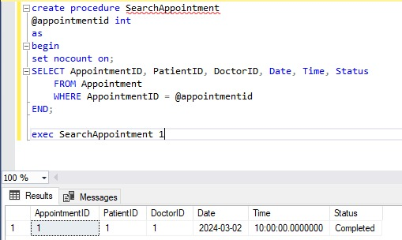

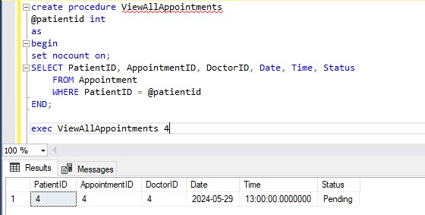

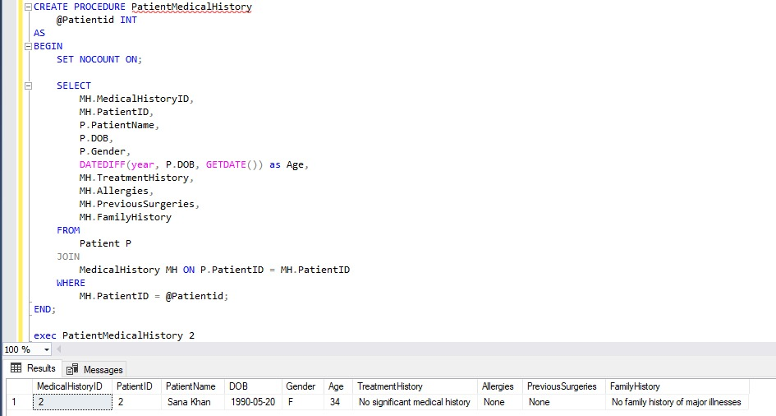

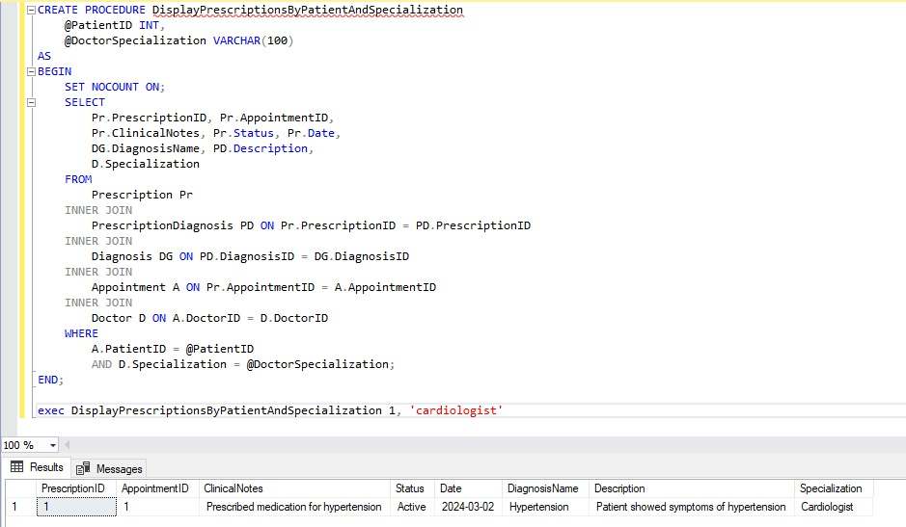

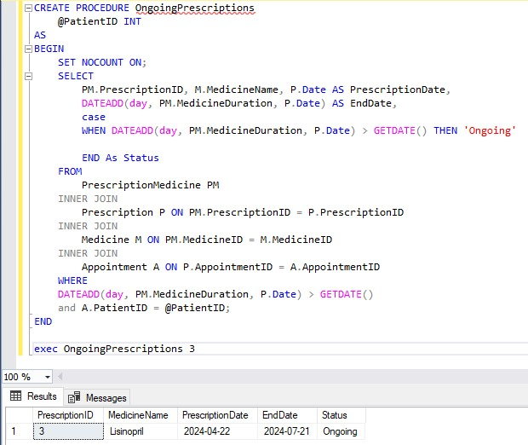

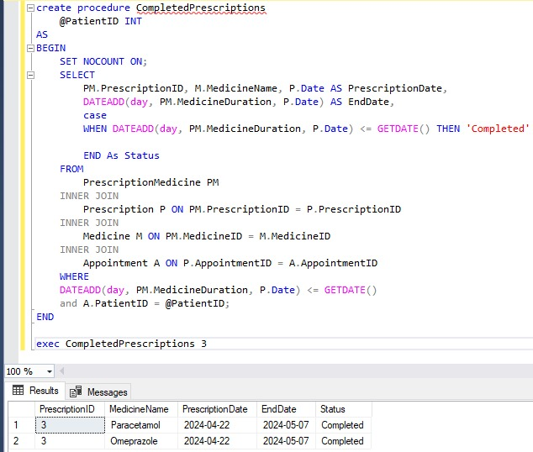

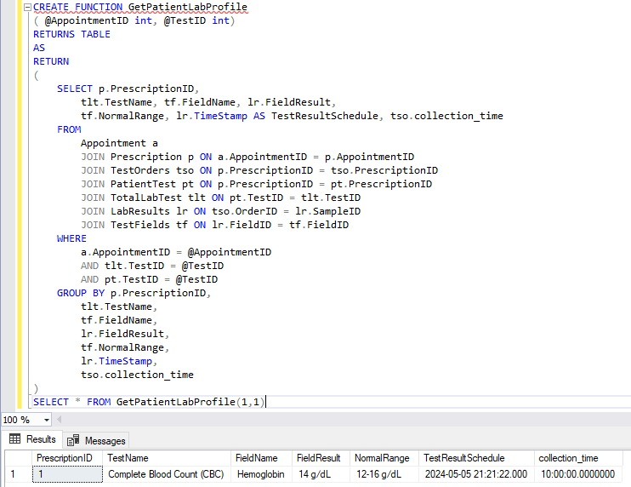

## FUNCTIONAL REQUIREMENTS

### FR01: PATIENT REGISTRATION

|  |  |
| --- | --- |
| **Req. No.** | **Functional Requirements** |
| FR01-01 | Allowing new patients to register by capturing vital information such as their name, contact information, address, date of birth, and gender. |
| FR01-02 | It should support the assignment of a unique patient identifier to each registered patient. |

### FR02: PATIENT LOGIN

|  |  |
| --- | --- |
| **Req. No.** | **Functional Requirements** |
| FR02-01 | The system must include a secure login method for registered patients to access their personal health information. |
| FR02-02 | Patients must provide unique email and password credentials for authentication. |

### FR03: PERSONALIZED DASHBOARD

|  |  |
| --- | --- |
| **Req. No.** | **Functional Requirements** |
| FR03-01 | Upon login, patients shall be directed to a personalized dashboard displaying relevant information, such as appointments, recent diagnosis, and ongoing treatment plans. |

### FR04: MEDICAL RECORDS MANAGEMENT

|  |  |
| --- | --- |
| **Req. No.** | **Functional Requirements** |
| FR04-01 | The system should facilitate the creation, storage, and retrieval of medical records for each patient. |
| FR04-02 | It should support the recording of patients' medical history, allergies, medications, treatment plans and other relevant clinical data. |

### FR05: PATIENT PROFILE

|  |  |
| --- | --- |
| **Req. No.** | **Functional Requirements** |
| FR05-01 | Allow patients to view and update their personal details, including name, gender, date of birth, address, and contact information. |
| FR05-02 | Display a comprehensive overview of the patient's medical history, including past diagnoses, surgeries, and chronic conditions. |

### FR06: PRESCRIPTIONS

|  |  |
| --- | --- |
| **Req. No.** | **Functional Requirements** |
| FR06-01 | Allow patients to view active prescriptions and review prescription history.  Display detailed information about prescribed medications, including name and category, and dosage instructions. |

### FR07: APPOINTMENTS

|  |  |
| --- | --- |
| **Req. No.** | **Functional Requirements** |
| FR07-01 | Display a list of upcoming and past appointments, including date, time and doctor.  Allow patients to access specific details for each appointment, including the doctor's name, specialty, and contact information. |

### FR08: PRESCRIPTION-APPOINTMENT ASSOCIATION

|  |  |
| --- | --- |
| **Req. No.** | **Functional Requirements** |
| FR08-01 | Allow patients to access a list of prescriptions linked to specific appointments within their profile. |
| FR08-02 | Provide a clear indication next to each prescription of the associated appointment for which it was prescribed. |

## NON-FUNCTIONAL REQUIREMENTS

### NFR01: SCALABILITY

|  |  |
| --- | --- |
| **Req. No.** | **Non Functional Requirements** |
| NFR03-01 | The system needs to be built with scalability in mind to handle future increases in the quantity of data, users, and patients. |
| NFR03-02 | It should allow for the addition of further resources without affecting performance or reliability. |

### NFR02: USABILITY

|  |  |
| --- | --- |
| **Req. No.** | **Non Functional Requirements** |
| NFR05-01 | The user interface should be intuitive, user-friendly, and accessible to users with varying levels of technical knowledge. |

### NFR03: MAINTAINABILITY

|  |  |
| --- | --- |
| **Req. No.** | **Non Functional Requirements** |
| NFR06-01 | The system should be flexible, well-documented, and easy to maintain and upgrade.  It should adhere to coding standards and best practices to facilitate code reuse, debugging, and troubleshooting. |

## USE-CASE

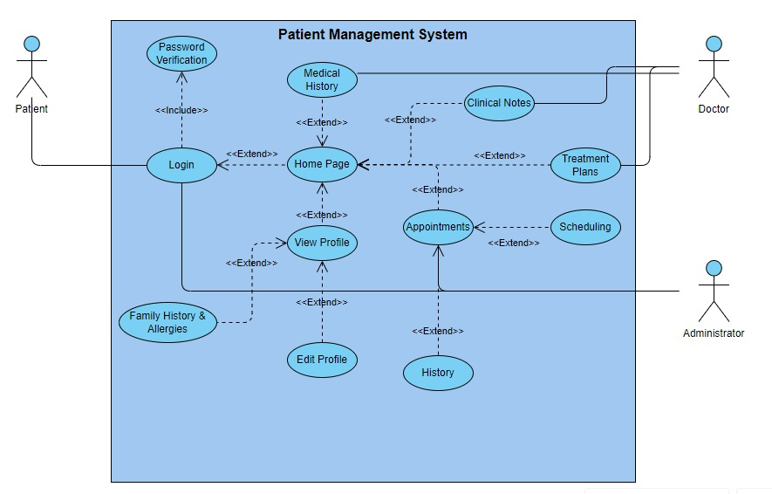

## WIREFRAME

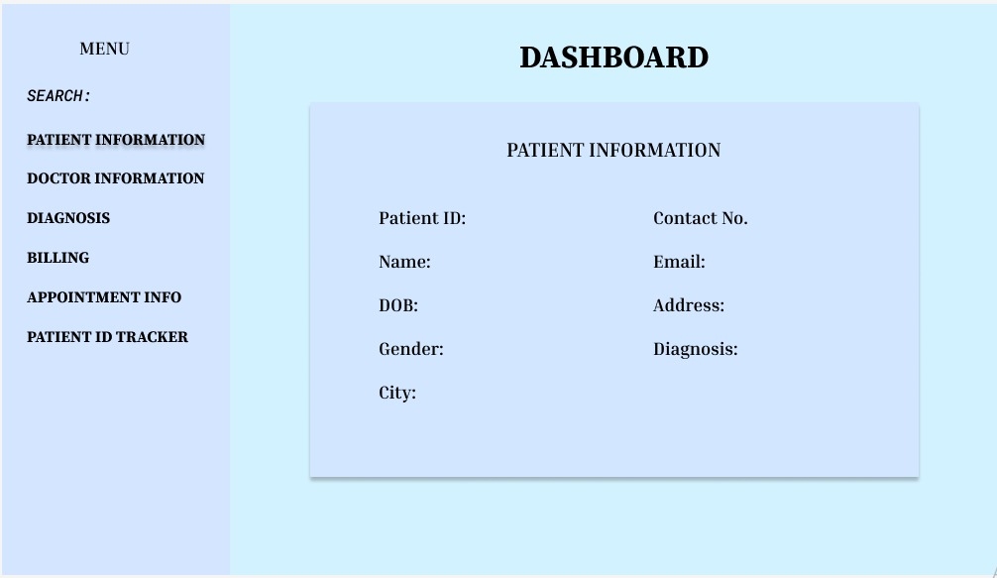

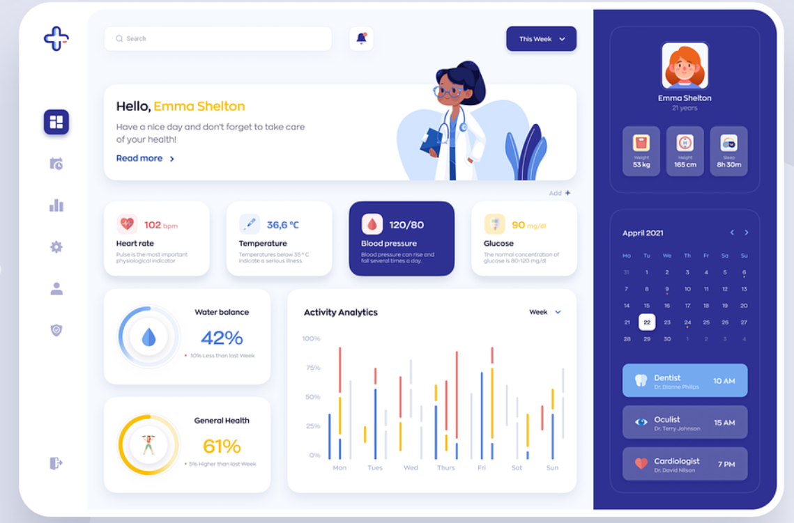

## FRONT-END

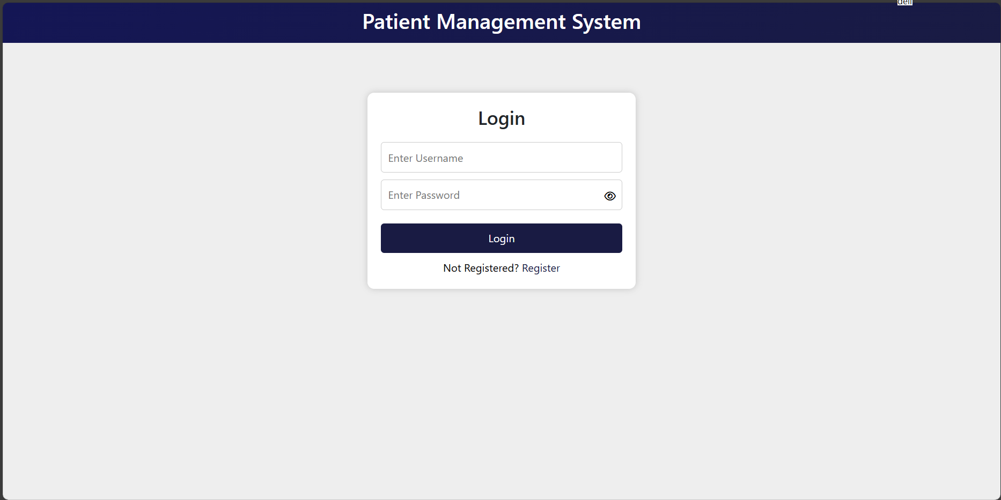

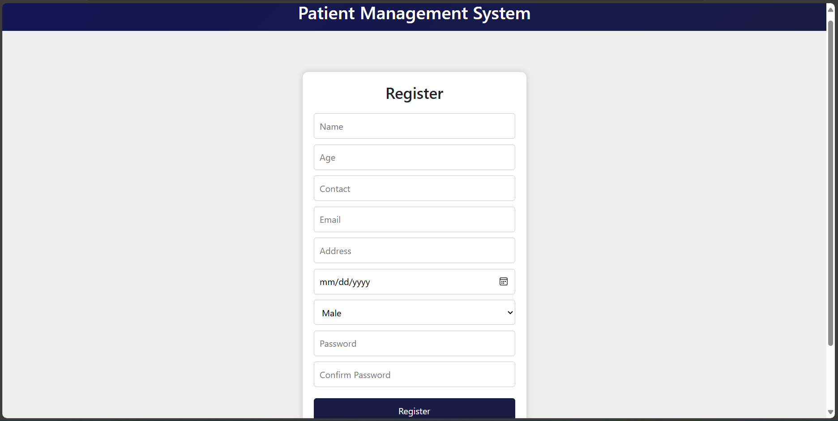

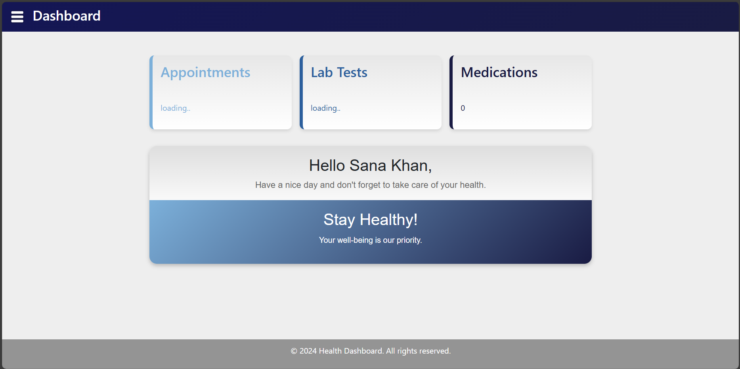

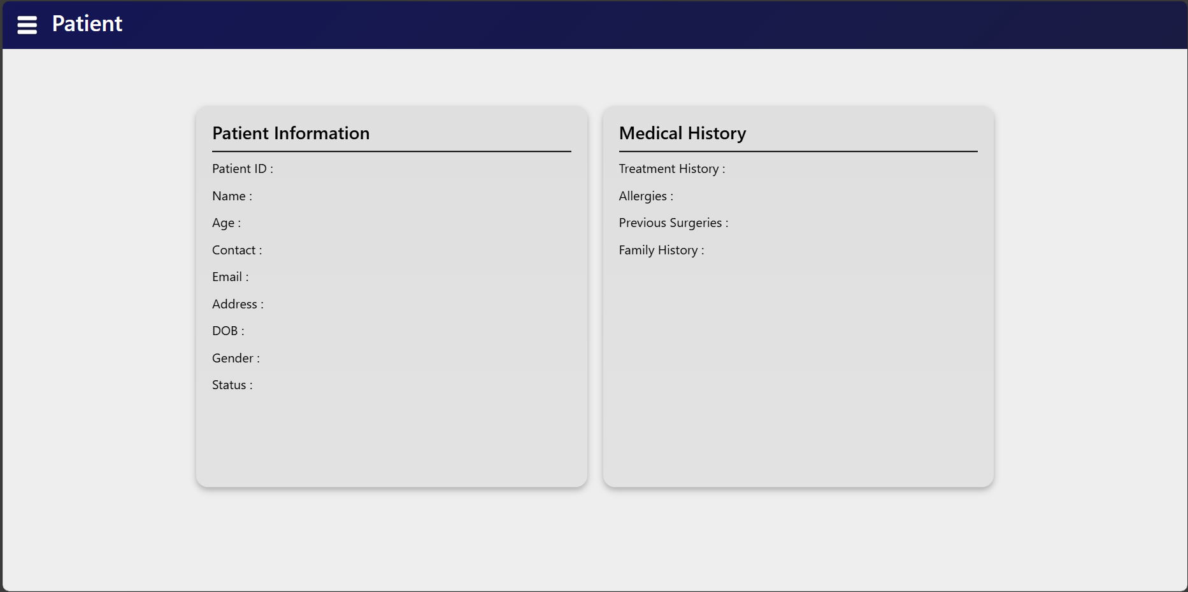

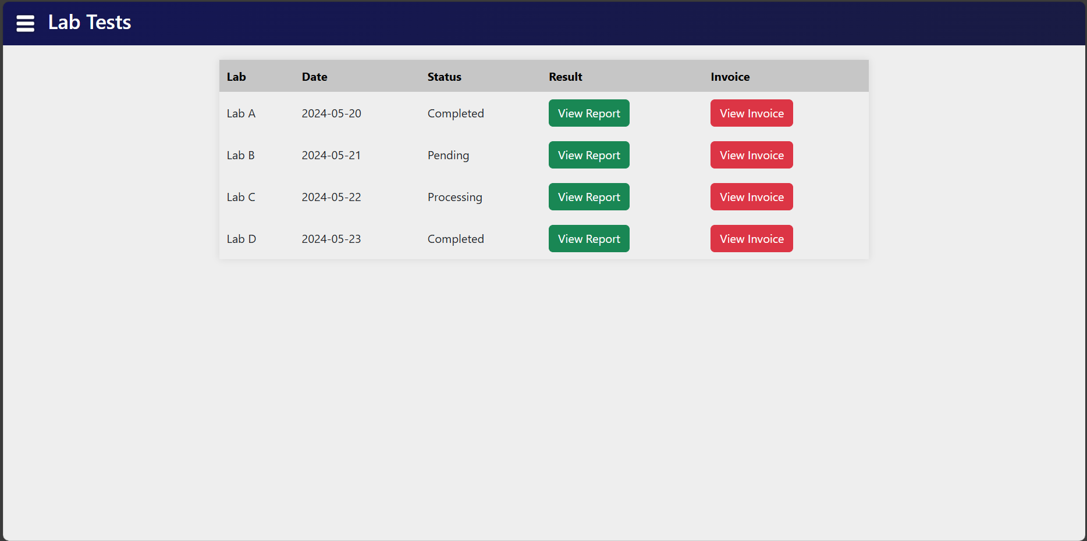

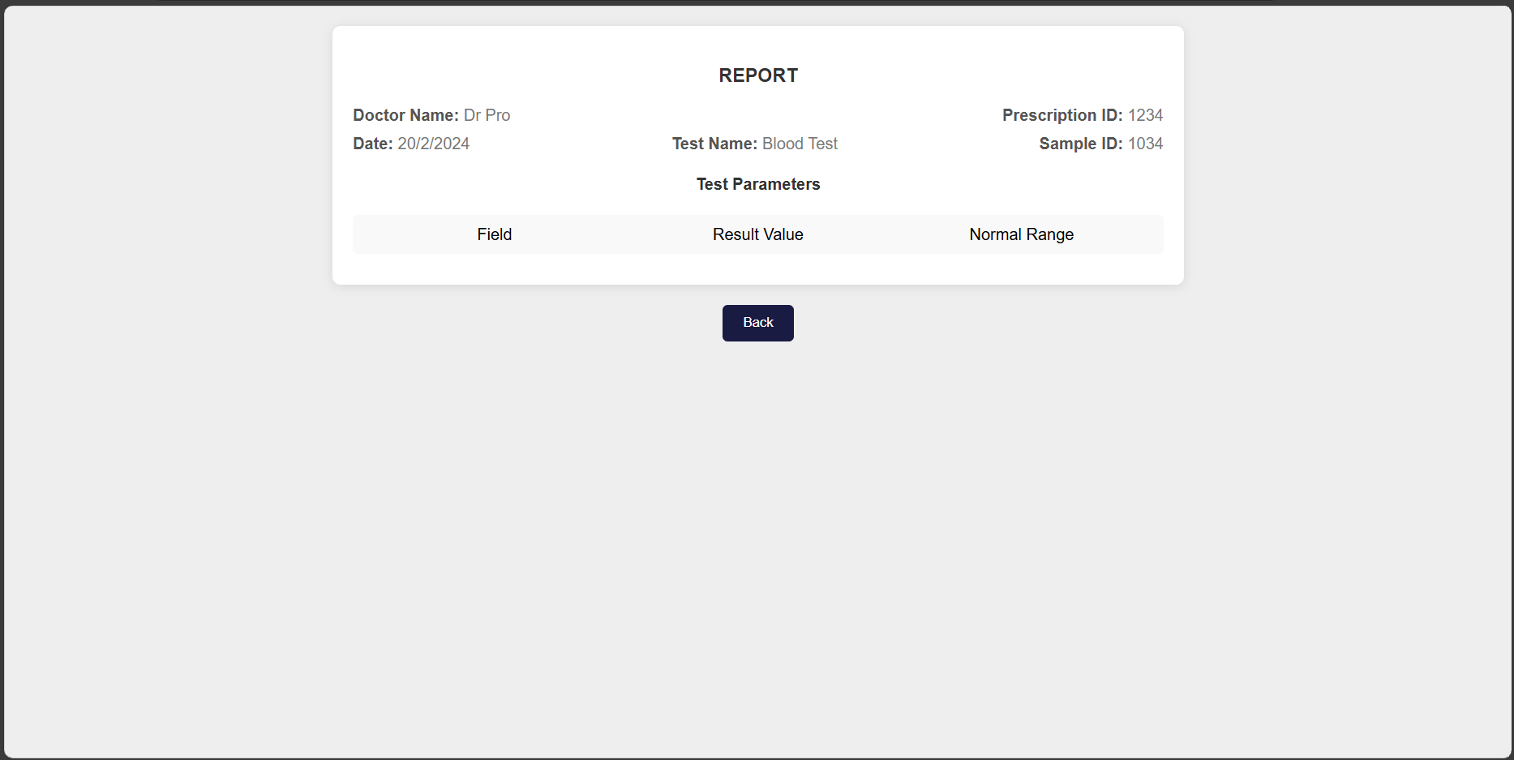

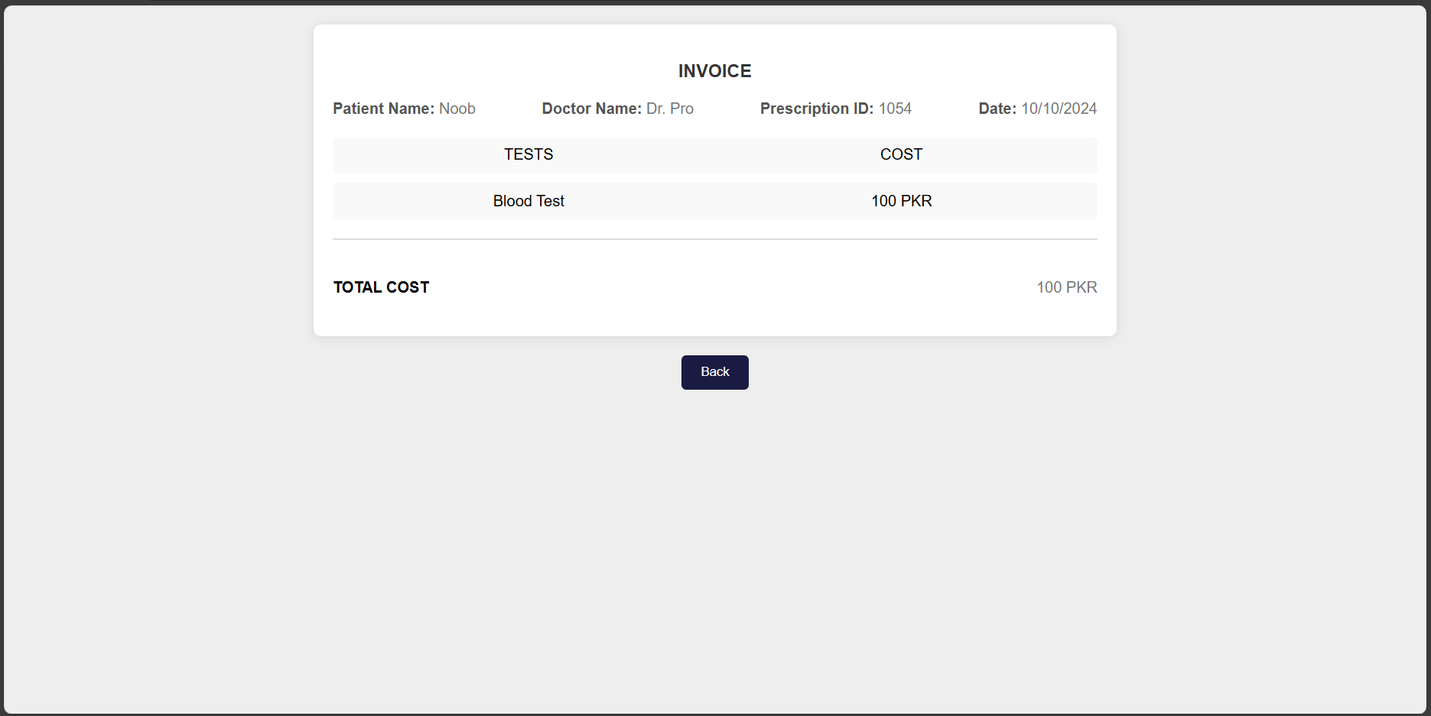

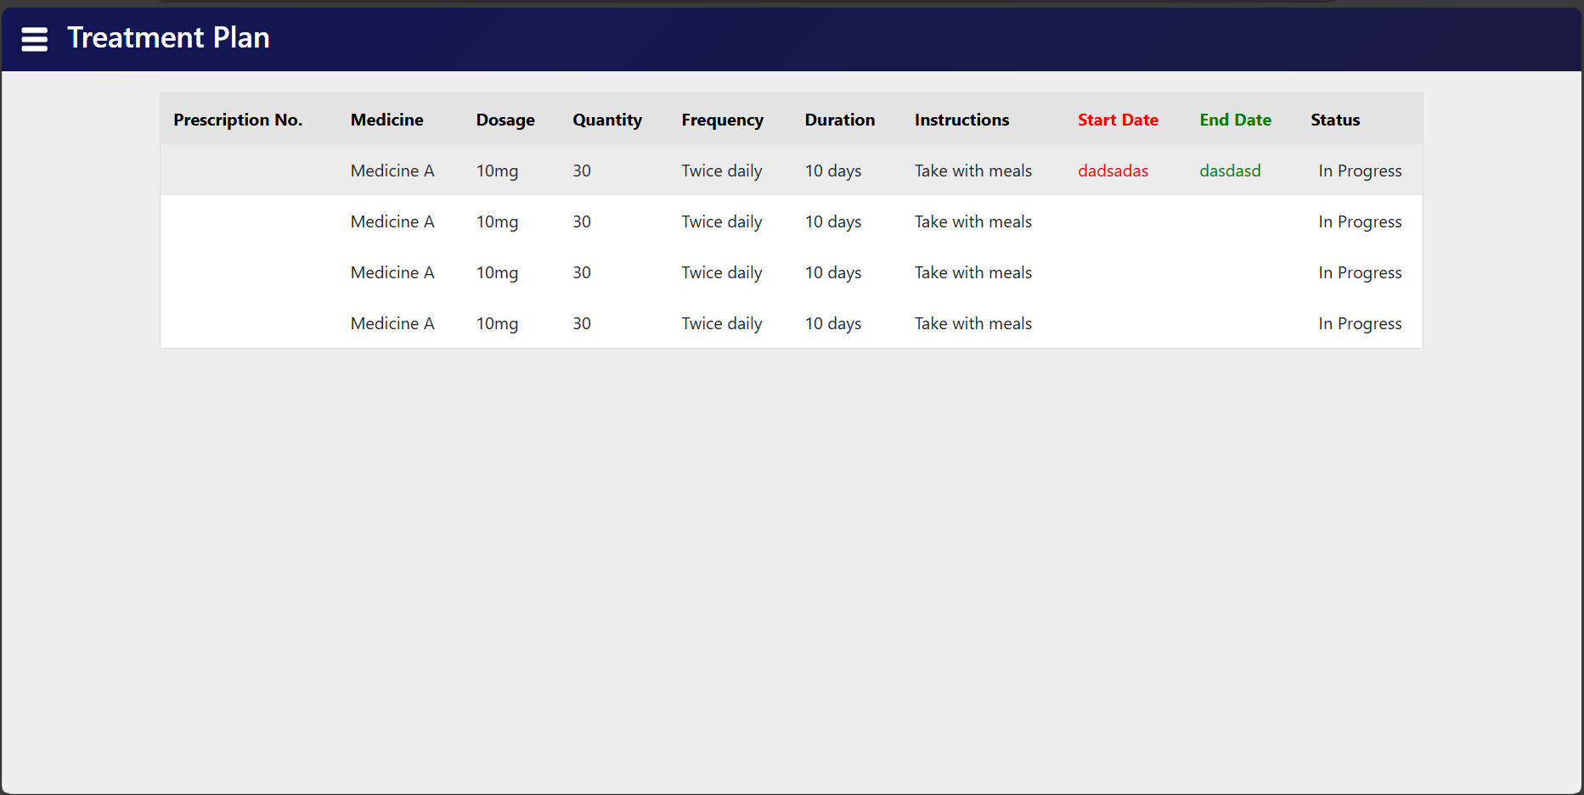

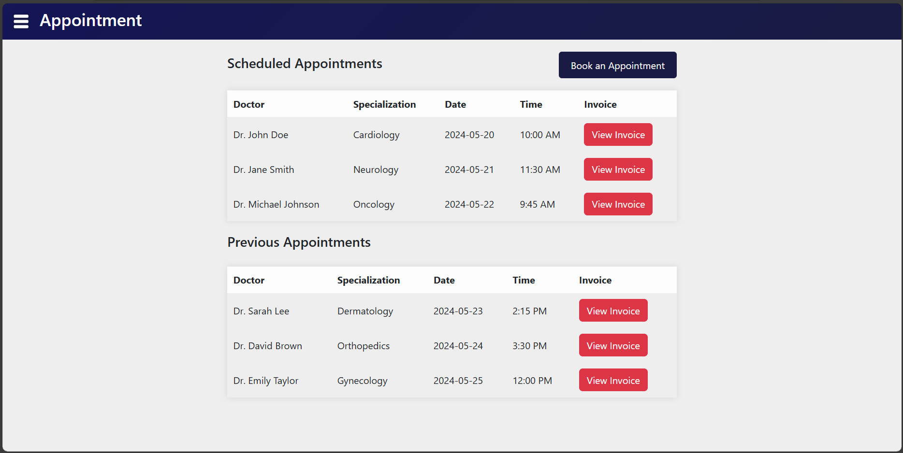

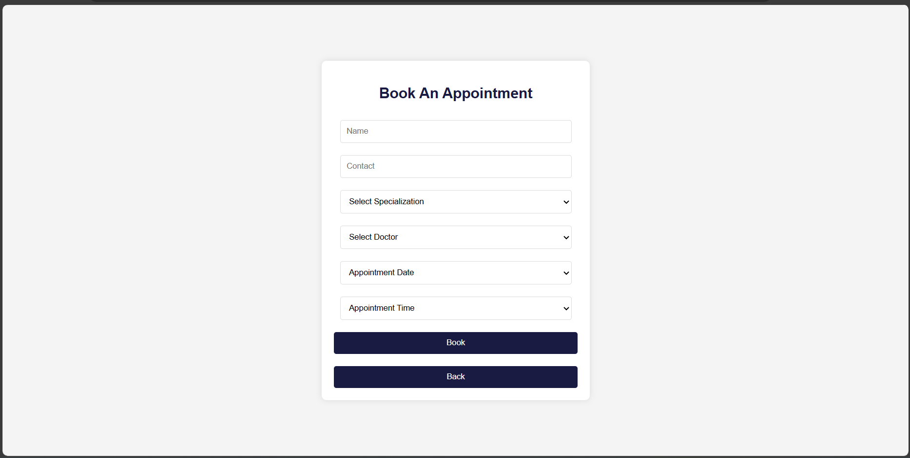

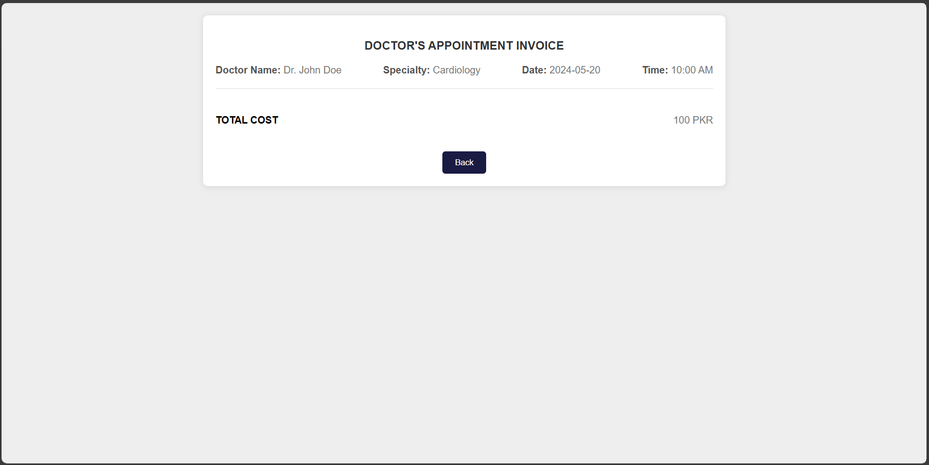

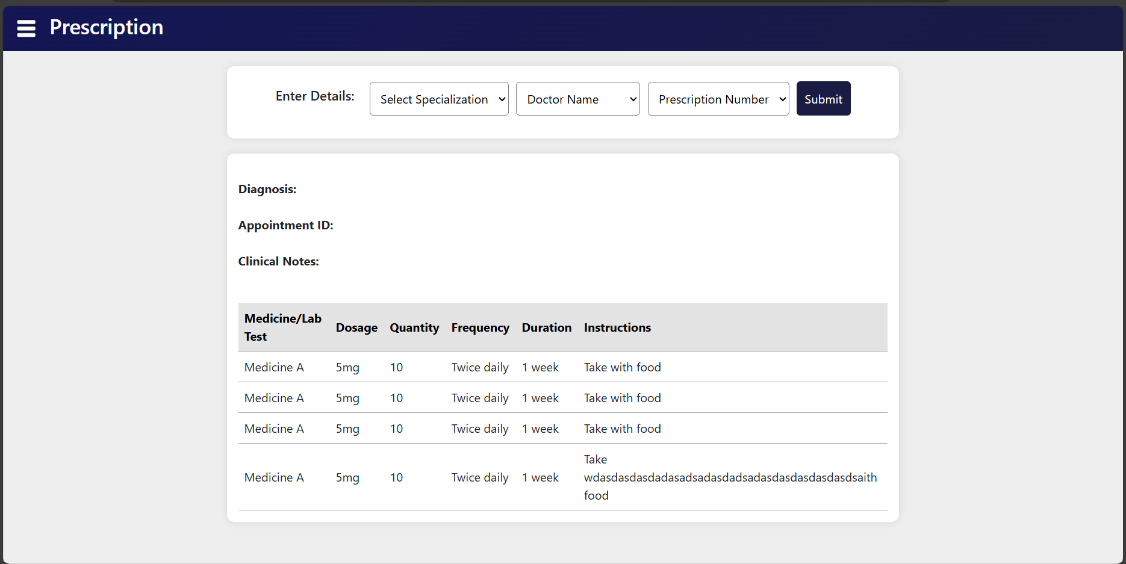

## DFD

### LEVEL 0

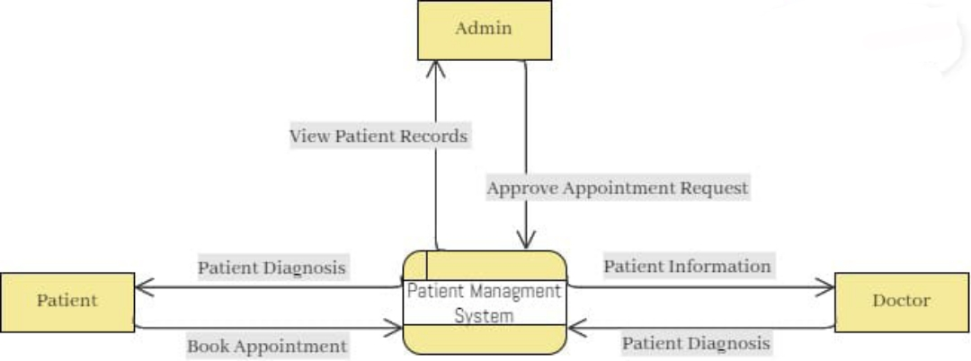

### LEVEL 1

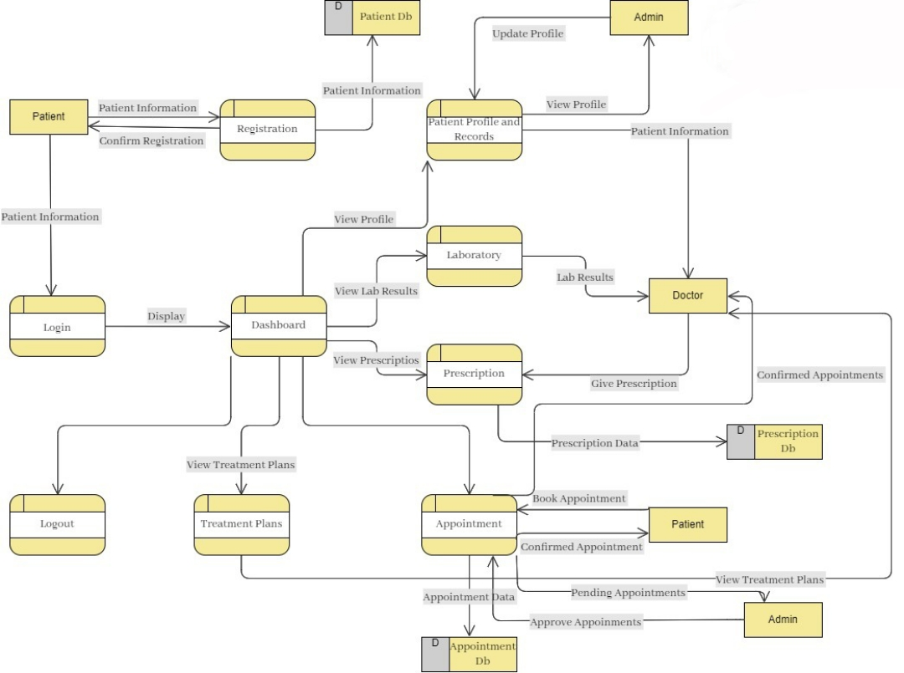

## GITHUB LINK

<https://github.com/ranabdullah01/Patient-Management>

## TESTING

### STATE TRANSITION TESTING

